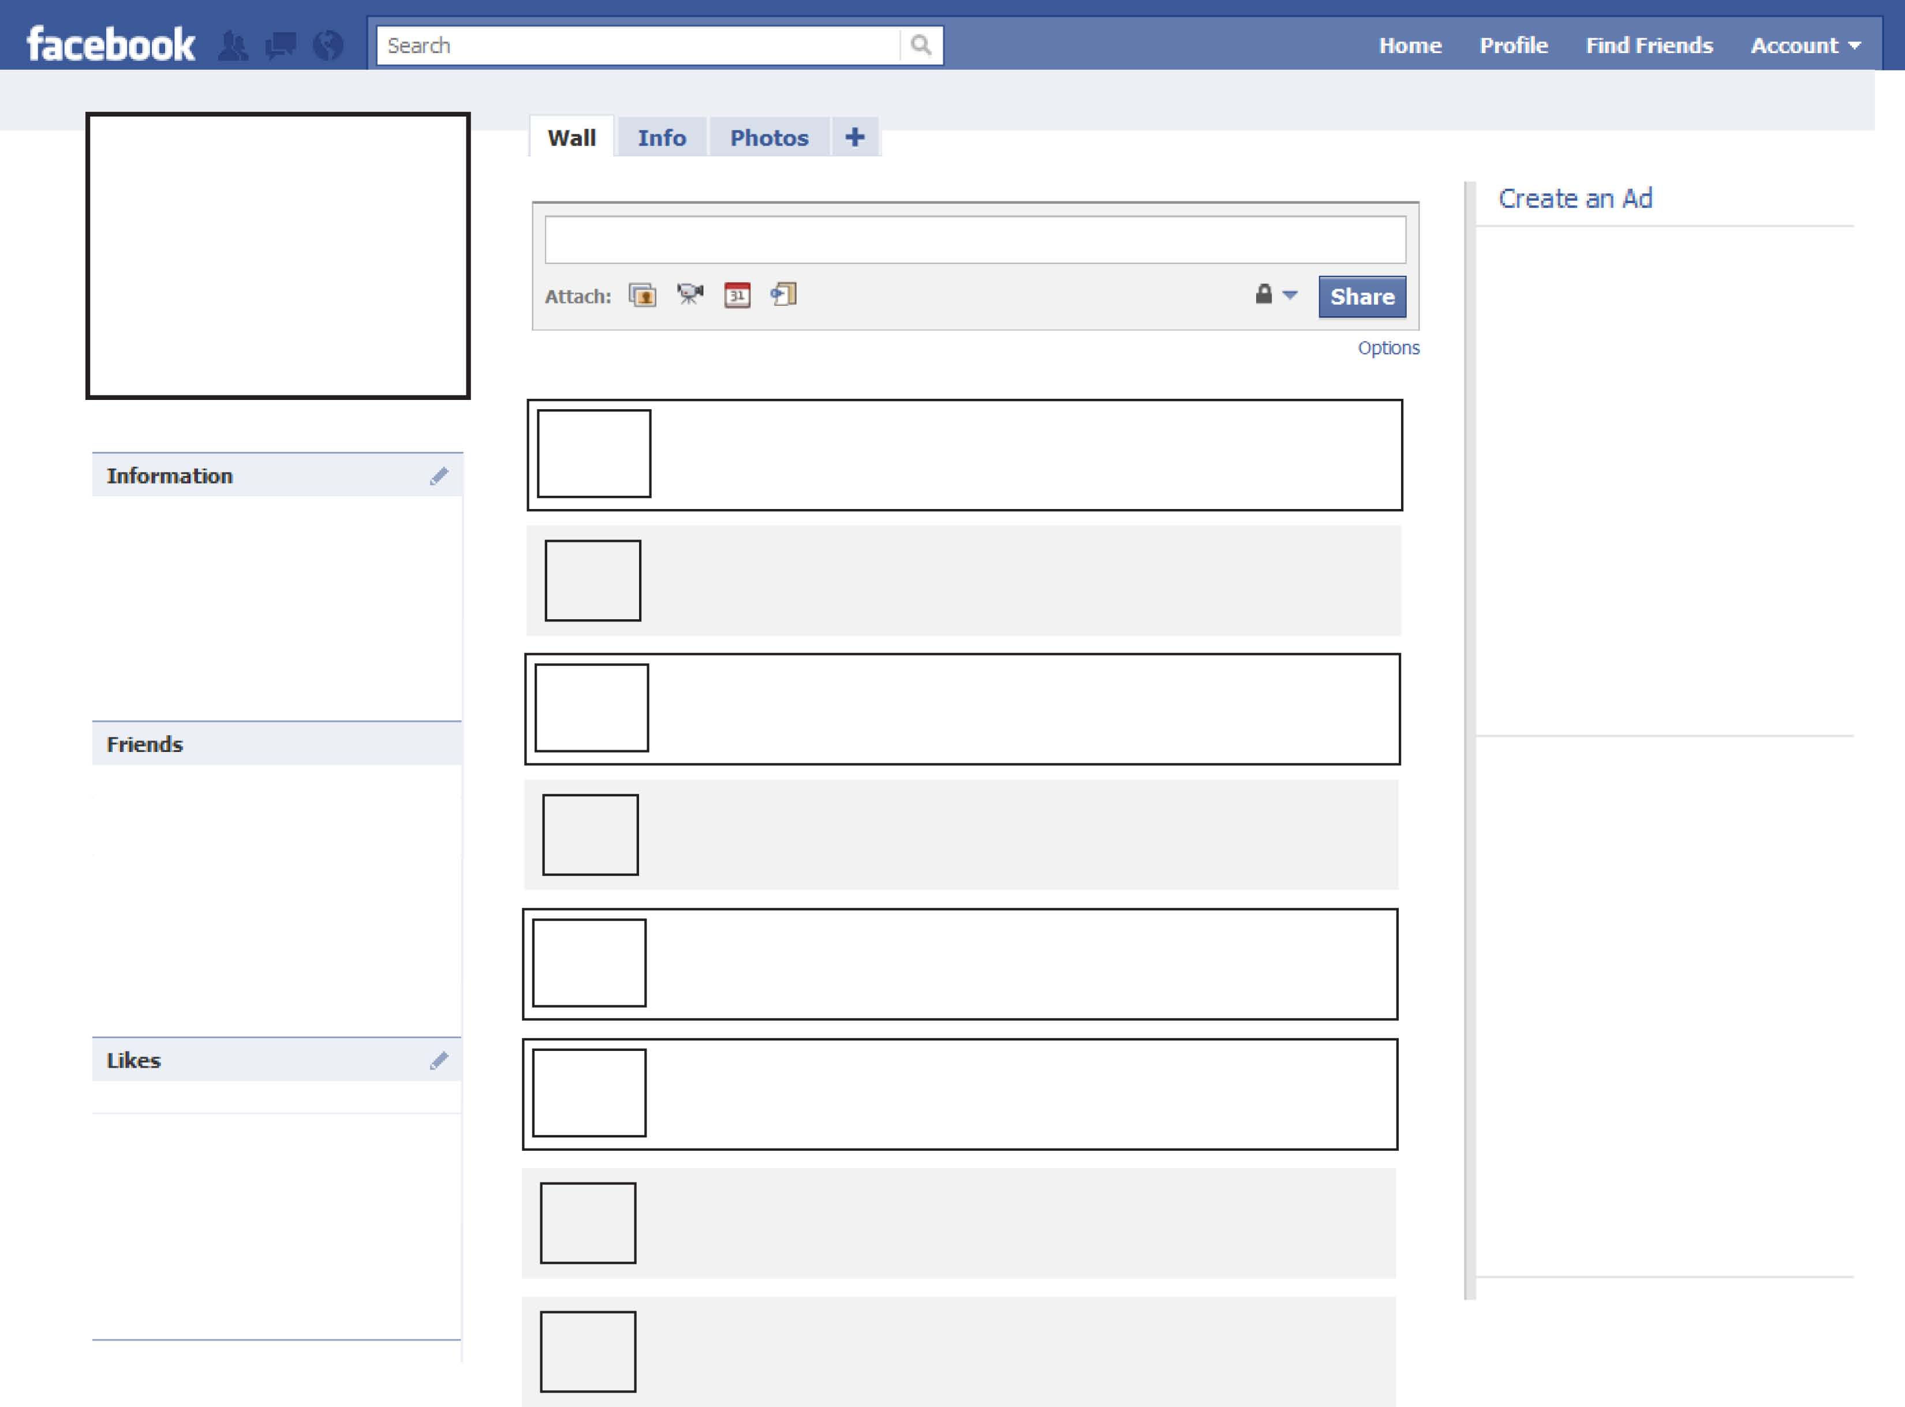
Status:
Hobbies:
What is the most extreme thing you’ve ever done?
Where would you like to travel?
Is this your first time at a sleep-away camp?
What is your favorite music? Give examples.
What type of movies do you like? Give examples.
What are your favorite tv shows? Give examples.
What is your favorite food?
Birth Date:
Hometown:
What is your best friend like? Describe him or her.
Music:
Movies:
TV Shows:
Food:
Things in common:
Name:
Common:

Name:
Common:

Name:
Common:

Name:
Common:

Name:
Common:

